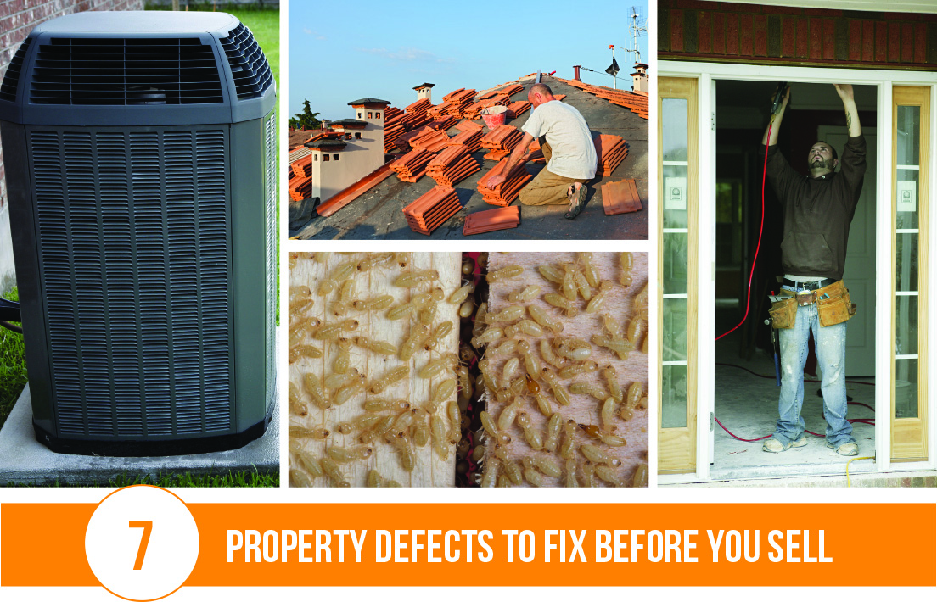

Broker’s Name  
Broker’s Lic #

**Your Name**

CalBRE Lic#  
555.555.5555  
youremail@mail.com  
yourwebsite.com

Ridding your home of critical defects and hazards goes a long way towards attracting buyers. Make your home more desirable by either eliminating these property flaws or factoring them into your pricing:

1. Outdated roof. Replacing an old roof or certifying your roof is in good condition helps to close your deal faster.
2. Cluttered gutters. Proper gutter maintenance can avoid damage to the foundation. Buyers also appreciate the cleanliness.
3. Old windows and doors. Creaky doors and jammed or sticking windows indicate your home is outdated, requiring pricey updates.
4. Broken appliances. While buyers expect to replace a few appliances, multiple dated or broken appliances necessitate major upgrades that put buyers off.
5. Termites. Pest infestations will have your buyers running away. Ensure your home is termite-free by obtaining a certificate of clearance.
6. Faulty air conditioning. An aged or broken HVAC system is a significant concern to buyers who will foot the costly bill — be prepared to negotiate a lower home price.
7. Cracked foundation. Faults in your foundation often signal more serious defects. Repair structural damage before listing your home to avoid complications with your buyer.

If you’re ready to list your home, give me a call today!