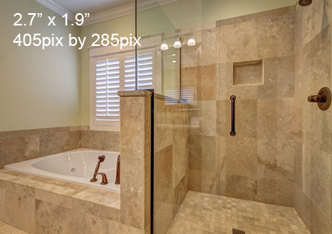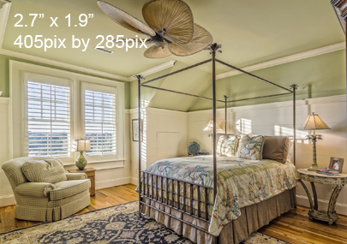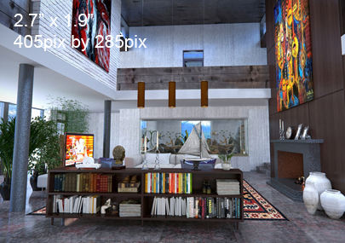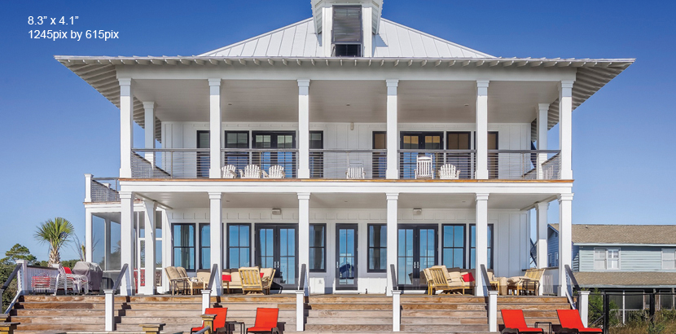

**Your Name**  
CalBRE Lic #  
555.555.5555  
yourwebsite.com  
youremail@mail.com

Sample text. Enter your text here.  
  
Beautiful 5 bedroom 4-1/2 bathroom home located just minutes from downtown. Huge master with separate sitting room. Bedroom with full bath located on lower level. Beautiful hardwood floors on the lower level.  
  
Great backyard with pool and patio made for entertaining.  
  
Ebis est, nihilles volor sunt fuga. Et officaboris eium dolest aut imetum aliquae. Et rest, et, occatur se dia debitae  
  
This house is a MUST SEE!

5 Bedrooms | 4-1/2 Baths

**$699,989**

Just Listed