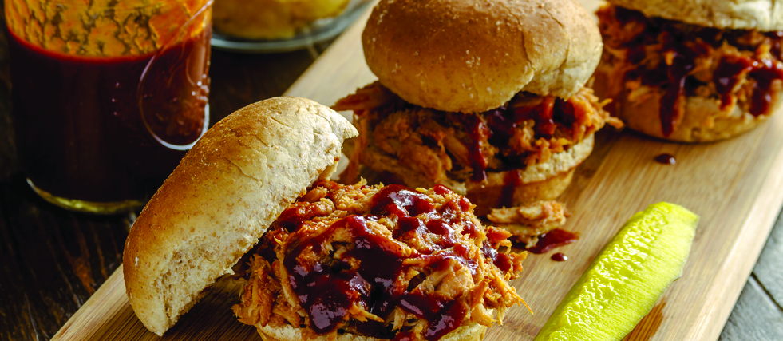

**Barbecued beef**

* 1 ½ cup ketchup
* ¼ cup brown sugar
* ¼ cup red wine vinegar
* 2 tbs Dijon mustard
* 2 tbs Worcestershire sauce
* 1 tsp liquid smoke flavoring
* ½ tsp salt
* ¼ tsp ground black pepper
* ¼ tsp garlic powder
* 1 (4 lb) boneless chuck roast

1. In a large bowl, combine ketchup, brown sugar, red wine vinegar, mustard, Worcestershire sauce and liquid smoke. Stir in salt, pepper and garlic powder.
2. Place chuck roast in a slow cooker. Pour ketchup mixture over roast. Cover and cook on Low for 8 to 10 hours.
3. Remove roast from slow cooker, shred with a fork and return to slow cooker. Stir meat to evenly coat with sauce. Continue cooking for approximately 1 hour.

**Sun Protection 101**

Follow these tips to soak up the sun without letting the harsh UV radiation damage your skin:

* Avoid direct exposure to sunlight between 10 AM and 4 PM when UV rays are most hazardous. Stay indoors or remain shaded under a tree, umbrella or other shelter.
* Apply sunscreen with a SPF of 15 or higher. Be sure the sunscreen is broad spectrum, providing protection against both UVA and UVB rays.
* Reapply every two hours, especially after swimming or sweating.
* When possible, wear clothing that covers your arms and legs, and a hat with a wide brim.
* Don’t forget about your eyes – wear sunglasses, preferably the wraparound variety, to keep your eyes and the sensitive skin around them safe from UV rays. Check for labels that say the lenses meet ANSI UV requirements or provide UV absorption up to 400 nanometers.
* Avoid tanning beds and sunlamps, which expose the skin to harsh UV rays and contribute to long-term skin damage.
* Take steps to protect your skin from the sun year-round in all weather types. UV rays are still harmful on cloudy and overcast days.

Ready to shade yourself from the sun in a new home? Call me to make an appointment!

**Your Name**

CalBRE Lic#  
555.555.5555  
youremail@mail.com  
yourwebsite.com

Broker’s Name  
Broker’s Lic #

555.555.5555 | yourwebsite.com | youremail@mail.com

June