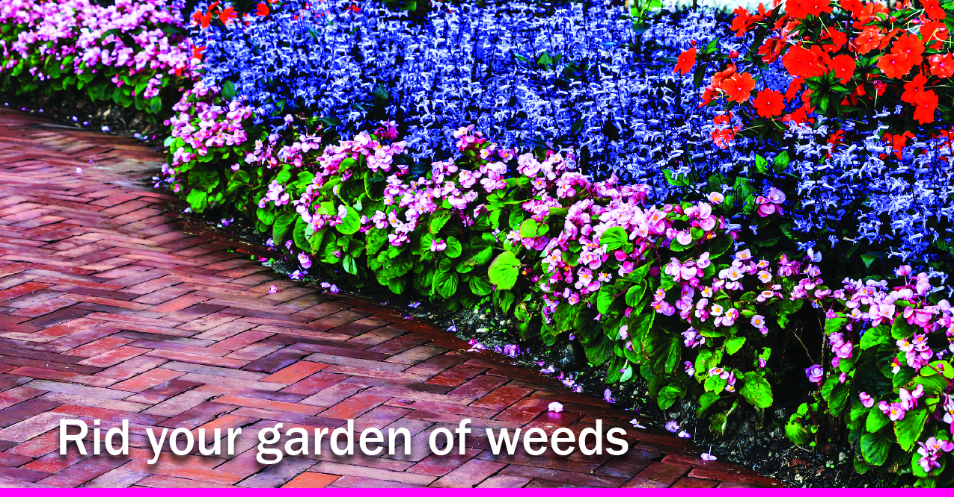

**Your Name**

CalBRE Lic #  
555.555.5555  
[youremail@mail.com](mailto:youremail@mail.com)  
yourwebsite.com

Nothing throws off your carefully tended garden like an invasion of pesky weeds. Follow these rules to say goodbye to unwanted plants in your garden:

1. Use the best tools.   
   The type of weeds in your garden will determine which extraction tool you need.

* Plants with tough, fibrous roots, like nutgrass and plantain, are best removed with a trowel or garden knife that can slice through soil and roots.
* Count on a spade or mattock to dig up deeplyrooted plants and stems, like quackgrass and torpedograss.
* Use a hoe or cultivator to dislodge new seedlings that may take root in your soil and sprout.
* Keep a pair of gloves on hand to protect your skin from irritants, bugs and thorns.

1. Time it right.   
   Pull weeds when the soil is moist to allow for effortless removal of roots and stems. During the summer, reduced heat in the mornings and late afternoons make extracting weeds less demanding. Work efficiently by focusing on one section of your garden at a time, methodically digging up unwanted plants over multiple days to ensure maximum removal in each area.
2. Prevention is key.  
   Dispose of pulled weeds in a bucket or bag to prevent new seeds from spreading. When new weeds sprout, dig them up immediately since they can duplicate quickly. Use mulch or groundcover to inhibit new seeds from reaching the soil and prevent buried seeds from sun exposure.

Ready to grow a beautiful garden in a new yard? Call me for an appointment!