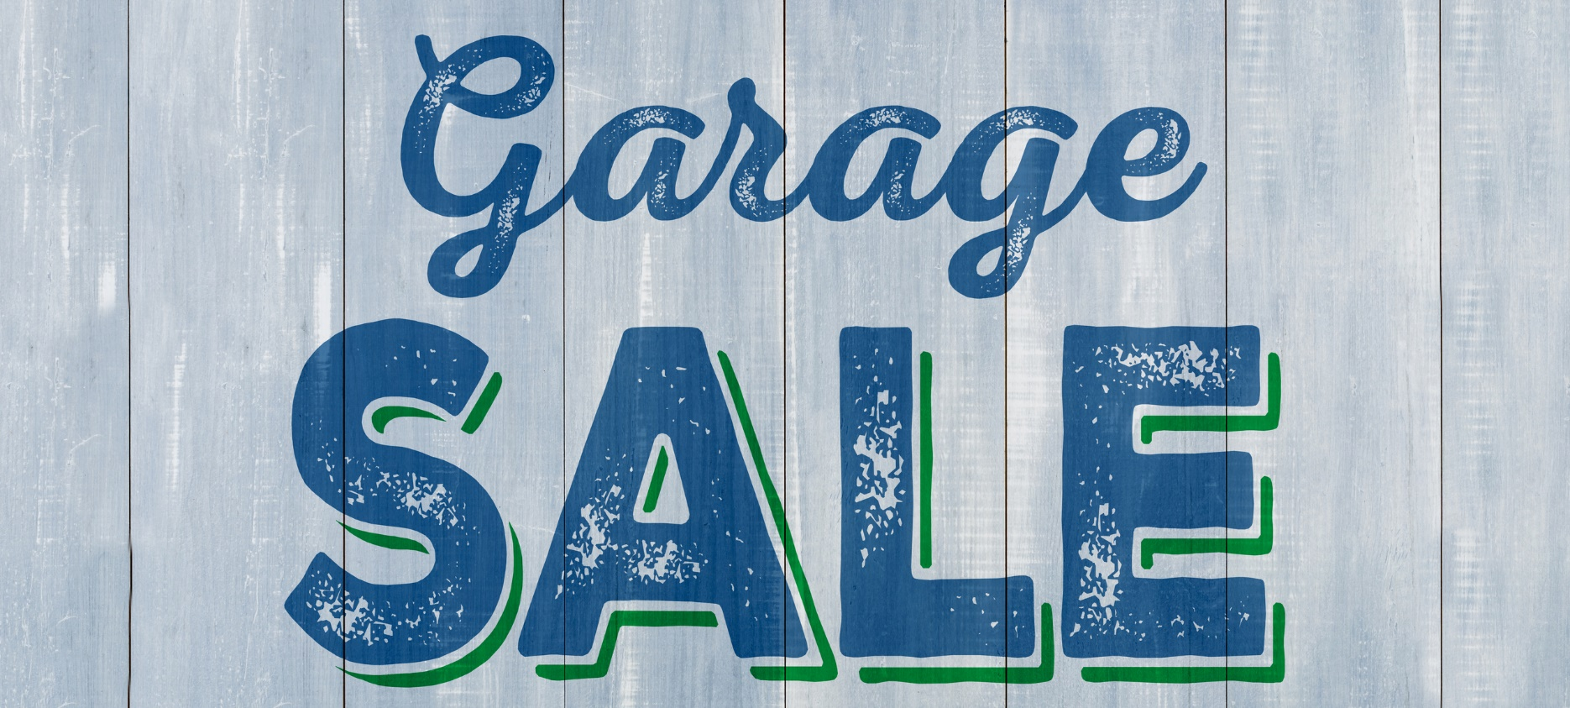

**Your Name**

NMLS ID  
CalBRE Lic#  
555.555.5555  
youremail@mail.com  
yourwebsite.com

Brkr Name  
Brkr Lic #

**Community Garage Sale**

Ready to clean house? Exchange your clutter for cash!

Hello, my name is **[Name]**, your neighborhood real estate agent. I’m sponsoring a **Community** **Garage Sale** in your neighborhood as a service to the community. Get to know your neighbors, clear the clutter, and make some cash in the meantime.

The event will take place at **[address/neighborhood]** on **[date]** from **[time]** to **[time]**.

Don’t worry about making signs, marketing will be taken care of. Just collect your inventory and invite your neighbors. More participants means more visitors!

RSVP at **[contact]** by **[deadline date]** with your contact information to participate.

Happy cleaning!