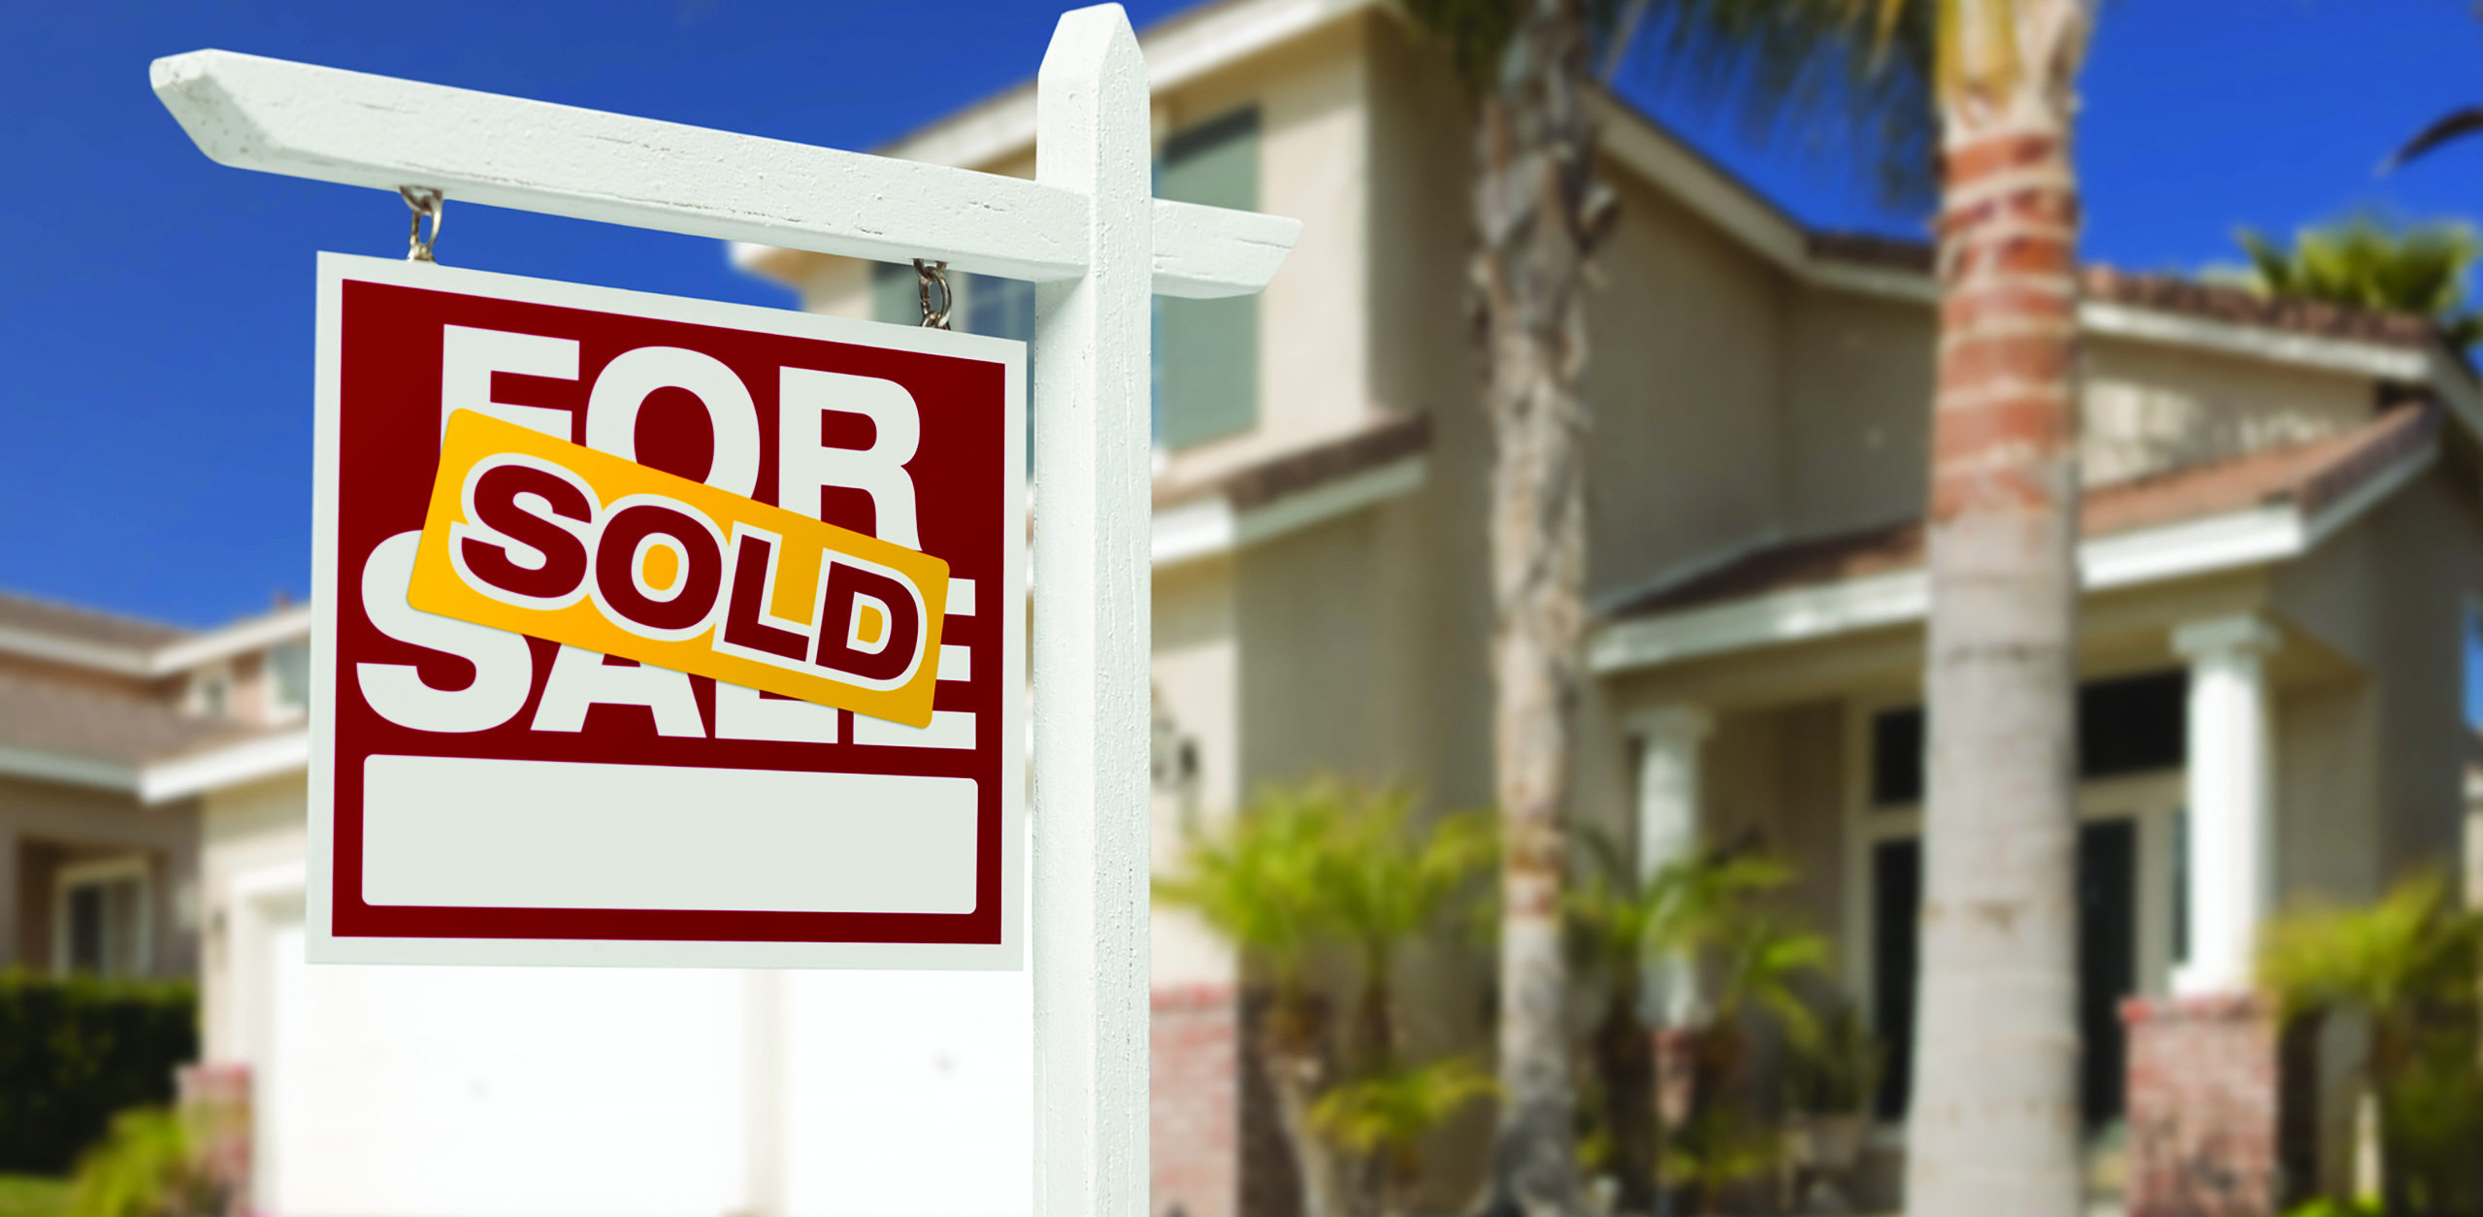

Your Name | CalBRE Lic # | 555.555.5555 | youremail@mail.com | yourwebsite.com

**Your Name**  
555.555.5555

**New Agent In Town**

Hello! My name is _____________, and I am a real estate agent new to your community. I work with a client-focused brokerage experienced in providing expert real estate services to homebuyers and sellers in the surrounding area. I am excited to expand our services into your neighborhood and provide you with the best real estate advice and assistance.

I look forward to seeing you around the neighborhood and getting to know you. In the meantime, don’t hesitate to call or email me your real estate questions!