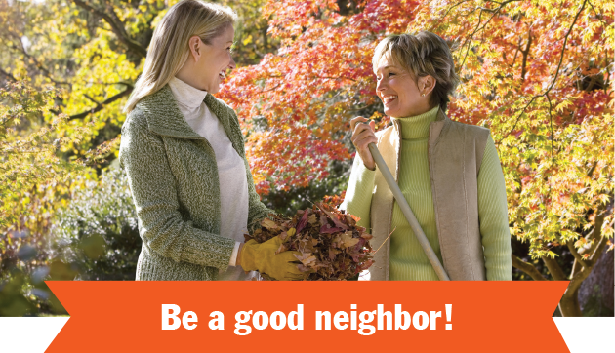

Whether you’re new to the neighborhood or have lived here for decades, it’s always a good idea to stay on your neighbors’ good sides. These relationships will help when there’s a disaster, you lock yourself out of your home, or when you go on long trips and need someone to keep an eye on your house.

Here is a list of actions to take that will help build positive relationships with your neighbors:

* **Introduce yourself** — Bring a small housewarming gift to new neighbors and visit neighbors on your block with treats during the holidays.
* **Exchange phone numbers** — Even though everything happens online today, it’s always a good idea to have the phone number of a neighbor in case of emergency.
* **Keep your yard tidy** — No one wants to be that person who doesn’t maintain their yard, causing neighboring property values to diminish. Make exterior maintenance and landscaping a priority, and hopefully your neighbors will follow your lead.
* **Discuss big exterior changes** — Before you build a fence or cut down a tree near the border of a neighbor’s yard, let them know. They will appreciate the courtesy and will likely return the favor.

Thinking of selling? I’m happy to help!

**Your Name**

NMLS ID  
CalBRE Lic#  
555.555.5555  
youremail@mail.com  
yourwebsite.com

Brkr Name  
Brkr Lic #