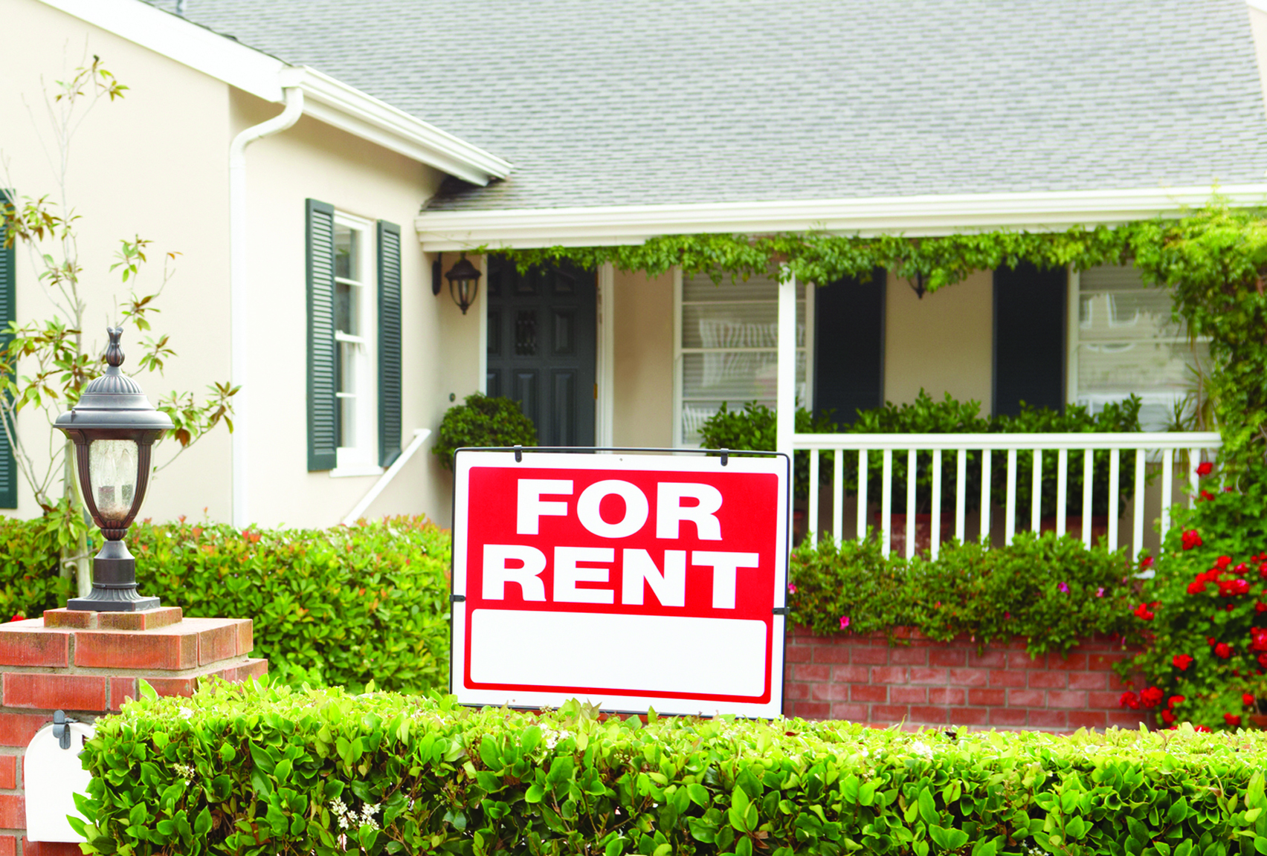

**Your Name**

CalBRE Lic#  
555.555.5555  
youremail@mail.com  
yourwebsite.com

Extra Information  
(delete if not needed)

Let me manage your property

Want to get the most out of your rental property? My experienced property management company provides the services and care you need to ensure your property is running smoothly — and for the highest return.

Whether you own a single family home or multiple rental units, I will deliver dependable oversight to your property and tenants.

My professional property management services include:

* thoroughly marketing your property for rent;
* screening prospective tenants, including background and credit checks, employment verification and prior eviction history;
* listing your rental unit(s) at or above market value;
* responding timely and professionally to tenant inquiries;
* maintaining the quality, security and cleanliness of your property;
* negotiating and enforcing lease agreement(s);
* collecting rent;
* compliance with all local and state laws;
* paying your bills and expenses;
* comprehensive accounting of funds; and
* remaining open and responsive to your communications at all times.

Put your rental property in the hands of a reliable and experienced property management company. Give me a call today!