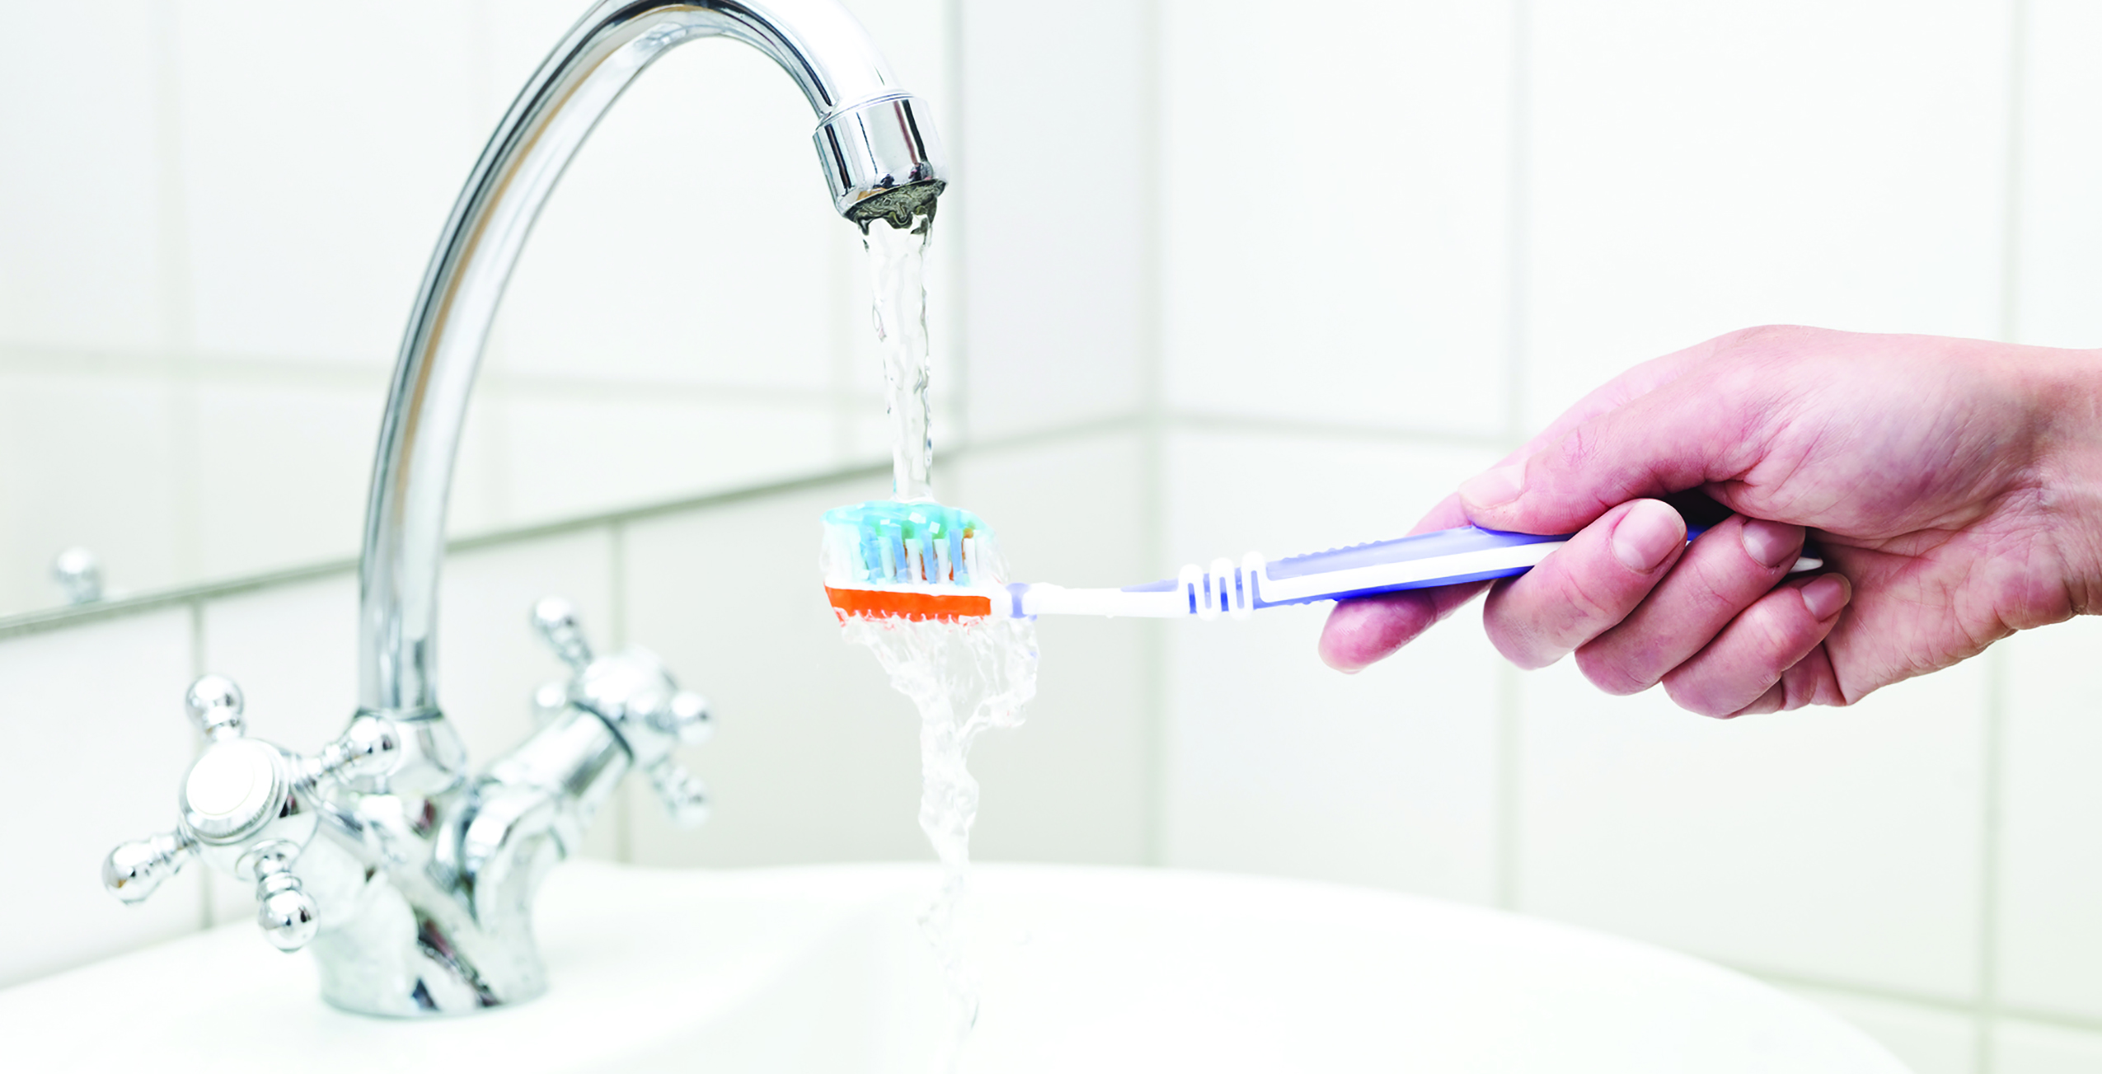

**Your Name**

CalBRE Lic #  
555.555.5555  
[youremail@mail.com](mailto:youremail@mail.com)  
yourwebsite.com

With California in a prolonged drought, being water-wise is more important than ever. Follow these seven tips to help the environment and save money on your water bill:

1. Install low-flow fixtures — Install showerheads with a flow rate of no more than two and a half gallons per minute. Adding aerators to your faucets will slow water use to one gallon per minute, helping you achieve tangible water savings.
2. Limit shower time — Decrease your shower time to five minutes with a low-flow shower head. You’ll use twelve and a half gallons of water or less, compared to thirty-seven and a half gallons used for an average 15-minute shower.
3. Brush wisely — Turn off the tap when brushing your teeth to save three gallons of water each time you brush.
4. Save when you flush — Add a displacement device to your toilet cistern to reduce the amount of water used per flush.
5. Wait for a full load — Use full loads in your washing machine and dishwasher to make you more water efficient.
6. Plant drought-tolerant plants — Native plants, succulents, sages and mallows make an attractive lawn and require much less water than grass. Water in the morning to help cut back on evaporation. Consider adding mulch to your plant beds to help your landscaping retain water.
7. Sweep, don’t spray — Save 80 gallons a year by sweeping walkways instead of hosing them down.

Looking for a new home that is water-bill friendly? Give me a call!

**Seven ways to  
 reduce water usage   
around the house**