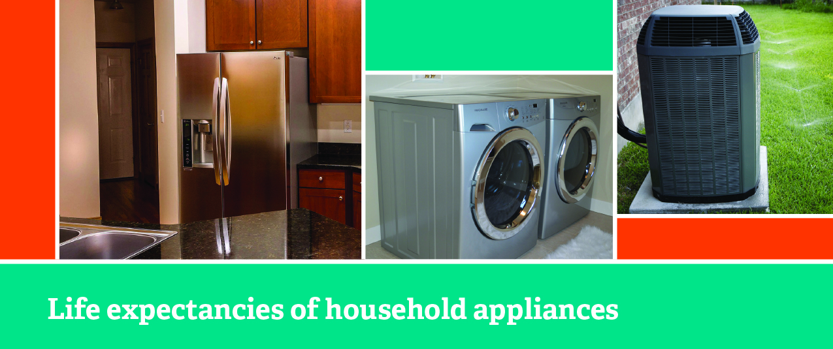

**Your Name**

CalBRE Lic#  
555.555.5555  
youremail@mail.com  
yourwebsite.com

Extra Information  
(delete if not needed)

As much as we don’t like to think about it, household appliances need to be upgraded at some point. Most warranties offer an easy solution to this problem, but it isn’t always so simple. Regular maintenance while planning for replacements can help extend the life of your appliances and prevent financial and emotional shock when they break down.

**Air conditioner:** Good-quality central air conditioners can last up to **20 years**, with many replacement parts readily available.

* Filter cleaning or replacement improves efficiency and protects the health of the evaporator coil. The coil should be cleaned once a year.
* Problems may also arise from incorrect installation resulting in leaky ducts and low airflow. Consult an HVAC professional to ensure your AC is functioning properly.

**Dishwasher**: Dishwashers usually last no more than **10 years**.

* Pay attention to lime buildup — use a lime descaler once a year to extend the life of your appliance.
* Clean your dishwasher’s filter every six months to greatly improve its cleaning ability.

**Refrigerator**: Refrigerators need to be replaced about every **15 years**.

* Clean dusty condenser coils twice a year to improve performance and extend the life of your refrigerator.
* Clean door gaskets to ensure a tight seal and prevent stress to the refrigerator’s motor — gasket repairs can be costly.

**Washer/Dryer**: At an average of one load per day, all newer model washing machines and dryers can last up to **14 years**.

* Avoid overloading your washer to reduce the strain placed on its moving parts and extend its life.
* Clean the lint screen on your dryer after every load to improve circulation and eliminate fire hazards — use the long nozzle on vacuum to clean lint missed by the screen.

**Water heater**: Depending on the type of water heater in your home (standard storage, tankless, heat pump or solar) it can last anywhere from **10 to 20 years**.

* Water heaters are subject to rust and mineral buildup. Flushing sediment from the tank and checking the anode rods once a year will help improve efficiency and longevity. Replacing the anode rods when needed can save you hundreds of dollars.
* Experts recommend repairing rather than replacing your water heater up until 10 years of use. When problems become more complicated after that, it’s time to consider upgrading.