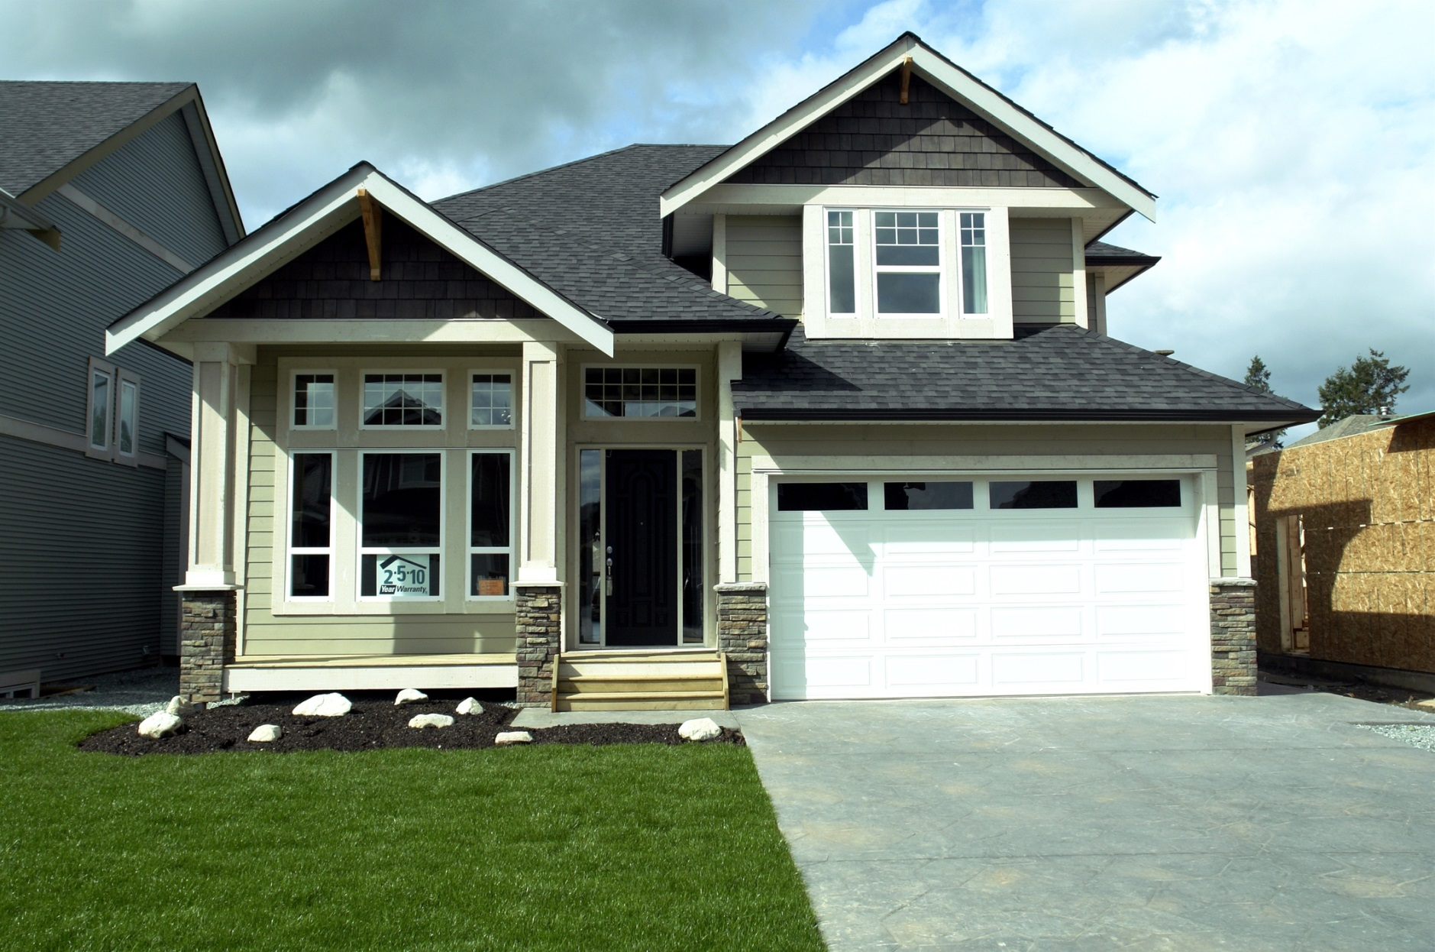

**Your Name**

CalBRE Lic#  
NMLD ID  
555.555.5555  
youremail@mail.com  
yourwebsite.com  
Broker Name  
Broker Number

Your text here

Your title  
HERE