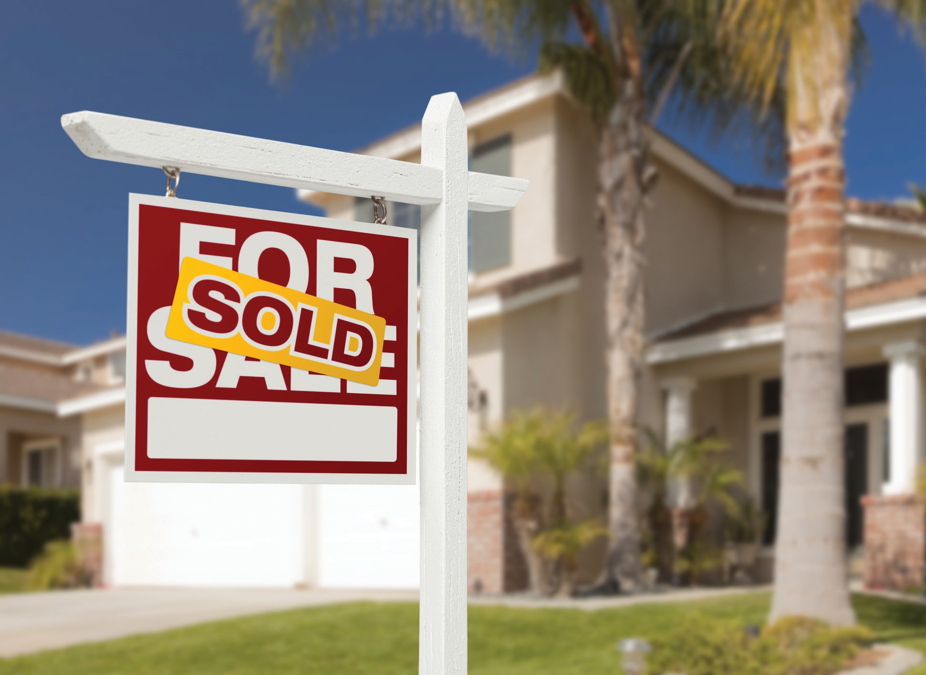

Need to sell a property in probate?

A probate sale requires knowledge of process. These steps include:
- Court appointment of the executor or administrator of the estate – The executor or administrator has authority to sell the property.
- Property appraisal – An appraisal is used by the executor or administrator to set a list price for the property with the assistance of the real estate agent.
- Marketing of the property – The property is aggressively marketed by the real estate agent to obtain the highest and best price and terms. Offers need to be at least 90% of the list price to be acceptable.
- Notification to all heirs – All heirs are notified of the accepted offer through a Notice of Proposed Action. If an heir objects to the offer, further court confirmation is required to execute the sale.
- Court confirmation and over-bidding – When court confirmation is required, a potential buyer may over-bid the accepted offer. Upon final court confirmation and execution of the sale, escrow is open and the transaction can proceed to close.
For probate sale assistance, please call me. You can rest assured that your transaction will be handled in the most professional manner.
Your Name
CalBRE Lic # 555.555.5555
email@mail.com website.com
Broker Name Broker CalBRE Lic #

Your address City, CA Zip

