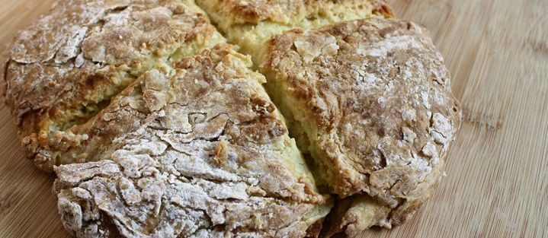

Irish soda bread

* 3 cups all-purpose flour
* 1 tbs baking powder
* 1/3 cup white sugar
* 1 tsp salt
* 1 tsp baking soda
* 1 egg, lightly beaten
* 2 cups buttermilk
* ¼ cup butter, melted

1. Preheat oven to 325 degrees F. Grease a 9x5 inch loaf pan.
2. Combine flour, baking powder, sugar, salt and baking soda. Blend egg and buttermilk, and add to the flour mixture. Mix until moistened. Stir in butter and pour mixture into prepared pan.
3. Baked for 65 to 70 minutes, or until a toothpick inserted into the bread comes out clean. Cool and wrap in foil for several hours or overnight for best flavor.

**Your Name**

CalBRE Lic#  
NMLS ID#  
555.555.5555  
youremail@mail.com  
yourwebsite.com

Broker’s Name  
Broker’s Lic #

555.555.5555 | yourwebsite.com | youremail@mail.com

March