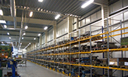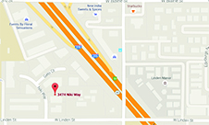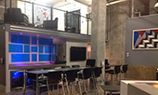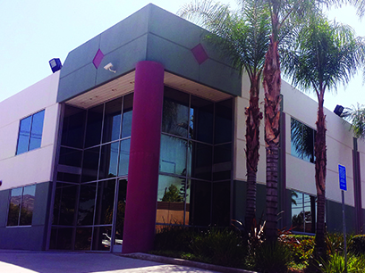

For Lease

+/- 35,143 SF Bldg, +/- 3,800 SF Office Space

**Your Name**Office Number  
Cell Phone Number  
Email Address  
Website

Total Space Available:  
Rental Rate:  
Property Type:  
Building Size:  
Year Built:

Zoning Description:  
Lot Size:  
No. Parking Spaces:  
Listing ID:  
Last Updated

**Great Space**

Property description