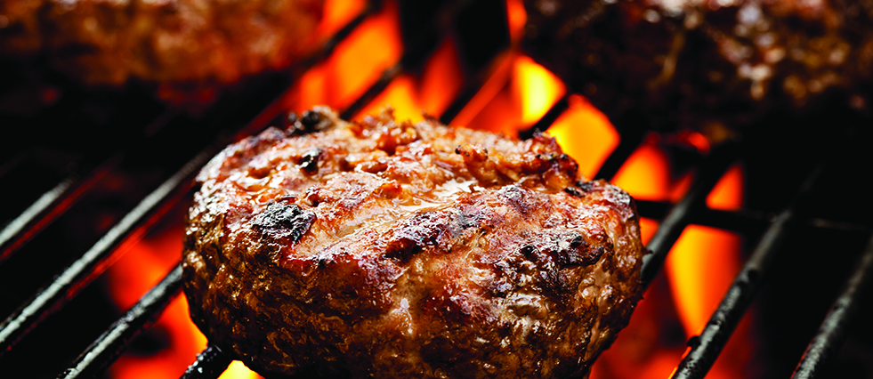

**Firework**Safety Guide

* Check with your local police department to see if fireworks are permitted in your city.
* Do not make your own fireworks. Only purchase legal fireworks that:
* are approved as “**Safe and Sane**” by the California State Fire Marshall (SFM) and display the official SFM seal; and
* are affixed with labels containing the licensed manufacturer’s name and directions.
* Never light fireworks indoors. Limit your light show to the street and pavement.
* Keep a bucket of water or hose nearby in case of accidents.
* Do not allow children to hold, light or otherwise handle fireworks and burned firework pieces. Even sparklers can cause serious injury to children.
* Do not stand over or hold fireworks while igniting them.
* Only light one firework at a time. Back up to a safe distance immediately after ignition.
* Do not pick up or attempt to relight a firework that has not ignited fully.
* Soak all used fireworks in a bucket of water before disposing of them.
* Keep your pets indoors and away from any fireworks to reduce the risk of injury to your pets and others.

To avoid firework hazards altogether, consider attending a public firework show instead.

Have a safe celebration and keep me in mind for all your real estate needs!

**Ranch burgers**

* 2 lb lean ground beef
* 1 (1 oz) package ranch dressing mix
* 1 egg, lightly beaten
* ¾ cup crushed saltine crackers
* 1 onion, chopped

1. Preheat grill for high heat.
2. In a bowl, mix ground beef, ranch dressing mix, egg, crushed crackers and onion. Form into hamburger patties.
3. Lightly oil the grill grate. Place patties on grill and cook 5 minutes per side, or until well done.

**Your Name**

CalBRE Lic#  
555.555.5555  
youremail@mail.com  
yourwebsite.com

Broker’s Name  
Broker’s Lic #

555.555.5555 | yourwebsite.com | youremail@mail.com

July