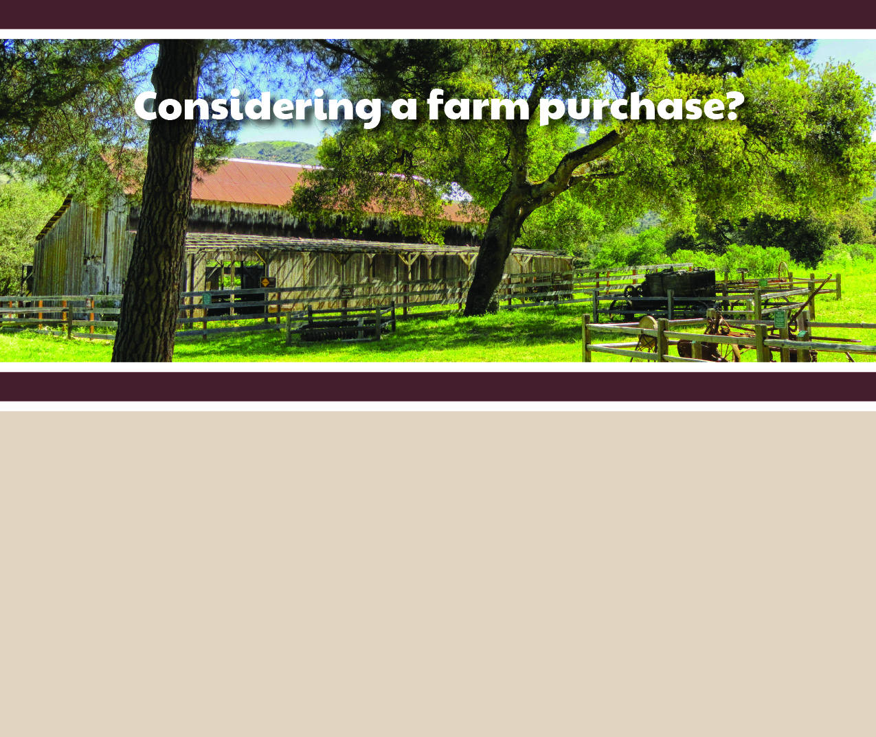

**Your Name**

CalBRE Lic#  
555.555.5555  
youremail@mail.com  
yourwebsite.com

Broker’s Name  
Broker’s Lic #

Are you thinking about buying a farm or ranch? Here are some considerations to get you started on the right track:

* The value of a farm takes into account many variables such as the number and type of buildings, equipment, crops, livestock, acreage and whether the farm includes an estate.
* What kinds of questions should you ask when touring a farm or ranch? For example, you’ll want to find out the production per acre, what farm equipment is included in the sale, the means of irrigation, what kinds of contracts the current owner has in place and who maintains the land.
* What is the land zoned for?
* What types of water rights are assigned to the property? California’s water rights laws are complex, and have recently changed to accommodate drought.

I specialize in farm/ranch purchases and can inform you on the many aspects of this complex transaction. Want to explore your options further? Contact me for assistance in realizing your dream of farm ownership!