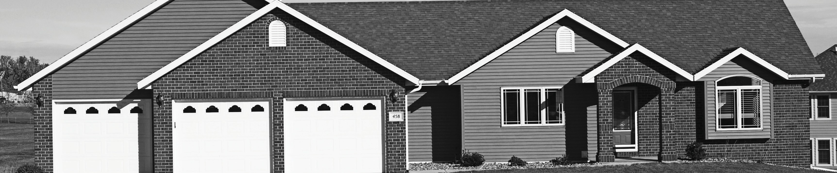
September

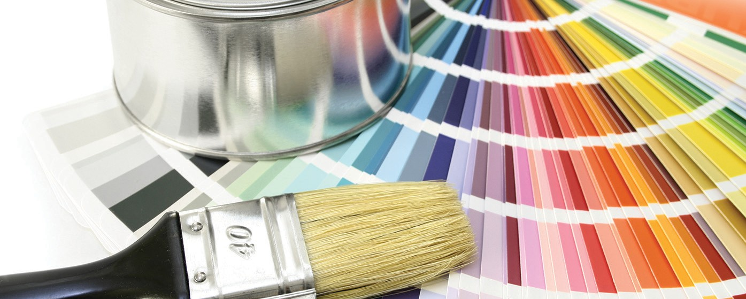
BIG DECORATING IDEAS FOR SMALL SPACES

Spinach and feta pasta
- 1 (8 oz) package penne pasta
- 2 tbs olive oil
- ½ cup chopped onion
- 1 clove garlic, minced
- 3 cups chopped tomatoes
- 1 cup sliced fresh mushrooms
- 2 cups spinach leaves, packed
- 1 pinch red pepper flakes
- 8 oz feta cheese, crumbled
- salt and pepper to taste
- Bring a large pot of lightly salted water to a boil. Cook pasta in boiling water until al dente; drain.
- Heat olive oil in large skillet over medium-high heat. Add onion and garlic, and cook until golden brown. Mix in tomatoes, mushrooms and spinach. Season with salt, pepper and red pepper flakes. Cook 2 more minutes until tomatoes are heated through and spinach is wilted. Reduce heat to medium, and stir in pasta and feta cheese. Cook until heated through.
8
- Paint and decorate in light and cool or neutral colors. Light blues, greens and neutrals make a space appear larger. Try for similar cool and neutral tones on walls, curtains and furniture.
- Add a mirror to reflect light. Hang a mirror vertically if you want the wall to appear taller, or horizontally if you want the wall to appear wider.
- Use a striped area rug to trick the eye. Your eye will expand the room in the direction of the stripes.
- Use furniture with a light visual weight. A glass coffee table or end table take up less visual space, and makes the room appear larger. Aim for furniture with clean, straight lines rather than bulky arms and legs.
- Use furniture wisely. If you’re in love with a bigger piece of furniture, make that one heavy piece the focal point. Make sure accessories and other furniture in the room are subtle and pair well with your focal point.
Your Name

CalBRE Lic#
555.555.5555
youremail@mail.com
yourwebsite.com

Broker’s Name
Broker’s Lic #
- Install floating shelves. Floating shelves give you storage space, without the heavy footprint of a bookcase.
- Cut the clutter. Move collections to a different room, or try rotating in seasonal accents to change up the look every few months.
- Watch your ceilings. For low ceilings, avoid tall furniture that will draw attention to it. For high ceilings, decorate vertically to draw your eye upwards.
Ready to upgrade to a bigger space? Give me a call for an appointment today!

555.555.5555 | yourwebsite.com | youremail@mail.com

