Dates to remember
Daylight Saving Time ends –
November 6
Veterans’ Day – November 11
Thanksgiving – November 24
Turkey Salad
- ¾ lb cooked turkey meat
- 2 stalks celery
- 2 green onions
- ½ red bell pepper
- 3 tbs mayonnaise
- 2 tbs Dijon mustard
- 1 tbs cider vinegar
- 1 tsp white sugar
- ¼ tsp salt
- Place cooked turkey meat, celery, green onions and red bell pepper in a blender or food processor. Finely chop using the pulse setting.
- Transfer the turkey mixture to a medium bowl. Mix in mayonnaise, mustard, vinegar, sugar and salt. Cover and refrigerate for 8 hours, or overnight. Serve on crackers or in a sandwich!
4 Reasons to list your home in the fall
You’ve likely heard that summer is the peak selling season. But listing in the fall has its advantages, too! Here are four top reasons to list your home this fall:
- Close before the tax year ends. It typically takes one to two months from signing a purchase agreement to closing, so sellers wishing to sell their home before the calendar year ends need to consider listing in October. This is particularly helpful if you’ve already purchased a home and want to finish the year with a level balance sheet.
- Buyers are more serious. Buyers who shop in the fall months are often more serious than spring and summer buyers. Many spring and summer buyers will buy if they can close before the school year starts, but the impetus for fall buyers is usually more immediate, like a job relocation or a changing family. This means deals are more likely to close and you’re less likely to be hassled by showing the home to unmotivated buyers.
- More attention from agents. The busiest time of year for real estate professionals is summer. Sellers who list in summer have to compete for time with their agent, lenders and inspectors who juggles multiple clients during the peak summer months. Selling in fall means your agent can devote their full attention to marketing and selling your home.
- Fall décor is cozy. Boost your home’s appeal by making it feel like a cozy home. Tasteful fall décor like wreaths, pumpkins and festive centerpieces can help buyers picture their families in your home.
Have questions about listing your home in any season? Contact me for more information!

Your Name/Team Name | 555.555.5555 | yourwebsite.com | Youremail@mail.com
November 2016
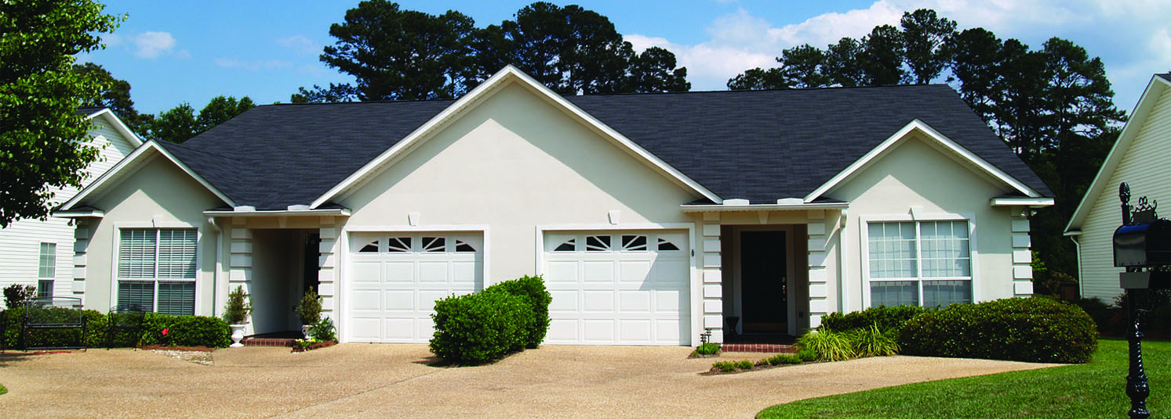


Time to buy income property
If you’ve considered investing in rental property, now is a great time to make plans. Low prices and low interest rates make conditions for investing in rental property the best we’ve had in 15 years.
Fundamental benefits of owning income property include:
- monthly cash-flow of spendable income;
- equity growth by loan principal reduction;
- price-value increase as an inflation hedge; and
- tax benefits of passive income and profits.
Remember to consider:
- Financing – Guidelines for financing income property are different from guidelines for financing a primary residence. How much do you qualify for and what down payment is required?
- Property size – Bite off only what you can chew. Will you be managing it yourself or do you intend to hire a property manager?
- Location – Look for property in familiar areas. Knowing the neighborhood or city you buy in makes it easier to rent and maintain the property for maximum benefit.
The window of opportunity is open. For a review on how to invest in income-producing property today, please call me!

Maintenance Tip!
Improve wisely to get the best out of your renovations with these tips:
- Make improvements that appeal to the largest number of buyers.
- Apply improvements you find in homes of similar value. Home sale prices in your neighborhood influence the value of your home, making some pricey improvements unlikely to pay off.
- Don’t subtract value with add-ons. Expanding your home beyond the original floor plan is costly and may push buyers towards similar, unaltered properties nearby.
- Pick projects that offer an 85% return or better, like upgrading the garage door, replacing the entry door or converting the attic into a bedroom.
- Choose projects that improve the home’s basic function over aesthetics and expansion.
- The exterior of your home makes the first impression. Apply a fresh coat of paint, clean oil stains from the driveway, remove weeds from the lawn and repair walkways.
Street Address
City, CA Zip
Your Name

