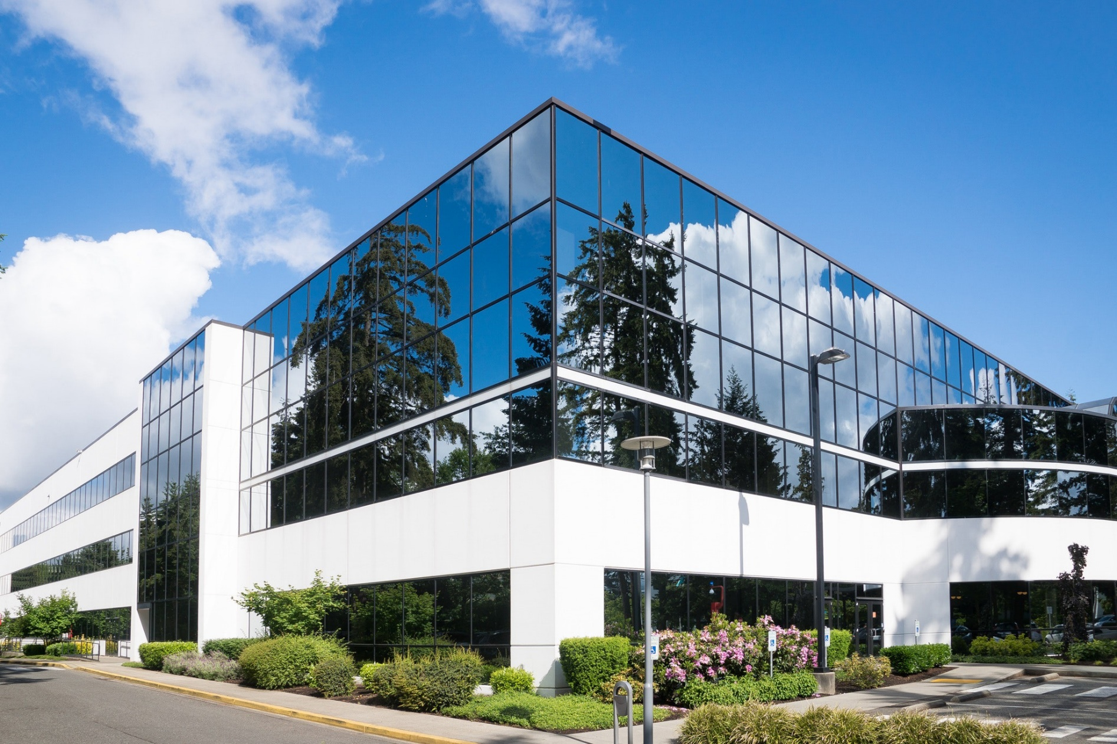

**Total Space Available:**

**Rental Rate:**

**Property Type:**

**Zoning Description:**

**Listing ID:**

**Property Description:**

Lorem ipsum dolor sit amet, ea nec fugit essent offi ciis. Malorum facilisis cum ea, cum ad vitae suscipit, per omnium probatus sapientem ei. Mutat animal facilis ex nec, id reprehendunt delicatissimi sea, sed mundi antiopam ut. Alia adhuc facete has an, sea modo consetetur id. Quo cu ignota accumsan. Vel et modo doming laoreet, has et meis ornatus.

**Broker Name**Broker NMLS ID  
Broker DRE Lic#  
555.555.5555  
brokeremail@mail.com  
brokerwebsite.com

**Commercial Real Estate Agency**

123 Address St, Suite 001

City, State, Zip

agencywebsite.com

**Your Name**NMLS ID  
DRE Lic#  
555.555.5555  
youremail@mail.com  
yourwebsite.com

**FOR LEASE**

**±7,000 SF**

**Office Space**

**Riverside, CA**