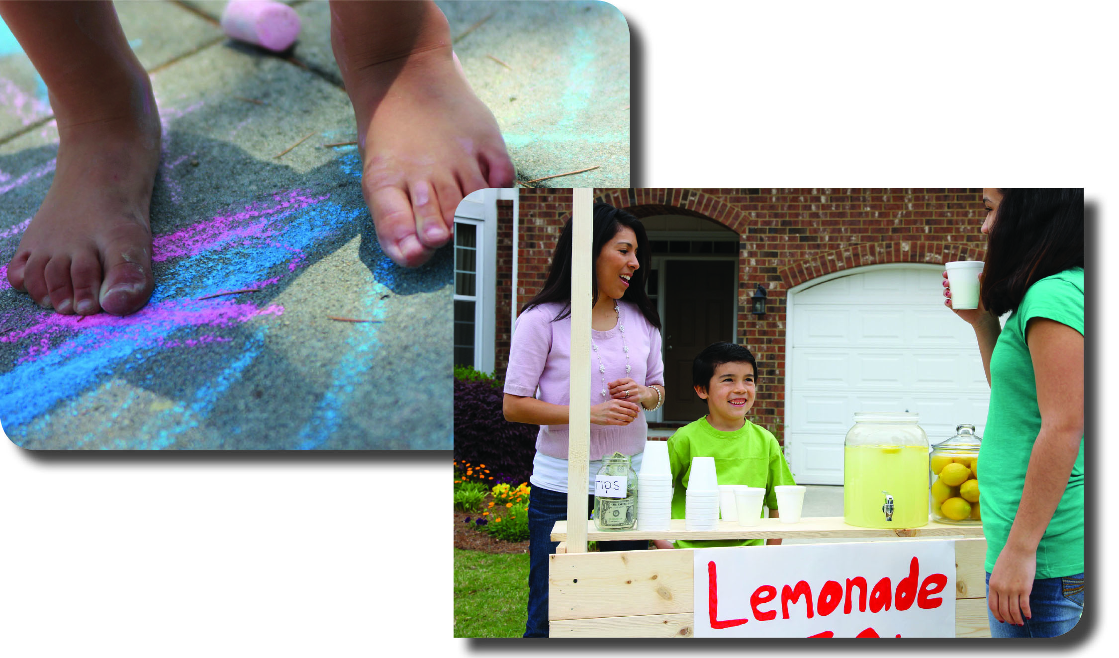

**Your Name**

CalBRE Lic#  
555.555.5555  
youremail@mail.com  
yourwebsite.com

Extra Information  
(delete if not needed)

Here are some ideas for keeping your kids happily occupied throughout the summer — giving you time to get things done.

Stock up on indoor activities. Keep board games, puzzles and a deck of playing cards on hand for when your kids need a break from the sun.

Go on backyard adventures. Plan a picnic or let your kids camp overnight in your own backyard.

Start a lemonade stand. Teach your kids a simple lemonade recipe and watch them become instant entrepreneurs. Bonus: They can practice their math skills counting change!

Invest in storytelling tech. Collect audiobooks your kids love and play them when you need some quiet time to yourself.

Create a chore chart. Make housekeeping a game! Assign simple chores to your kids and offer a small prize, like getting to choose what’s for dessert. Your kids will help you out and have fun in the process.

Decorate your sidewalks. Give your kids a bucket of sidewalk chalk and watch your yard transform into an art studio. Teach them to draw hopscotch frames for creative exercise.

Send your kids on a scavenger hunt. Give your kids a list of small items to collect from neighbors or friends. The first one to collect everything on the list wins!

Need more space for your family this summer? Give me a call today to find your ideal home!

Keep kids busy — and happy! —is summer