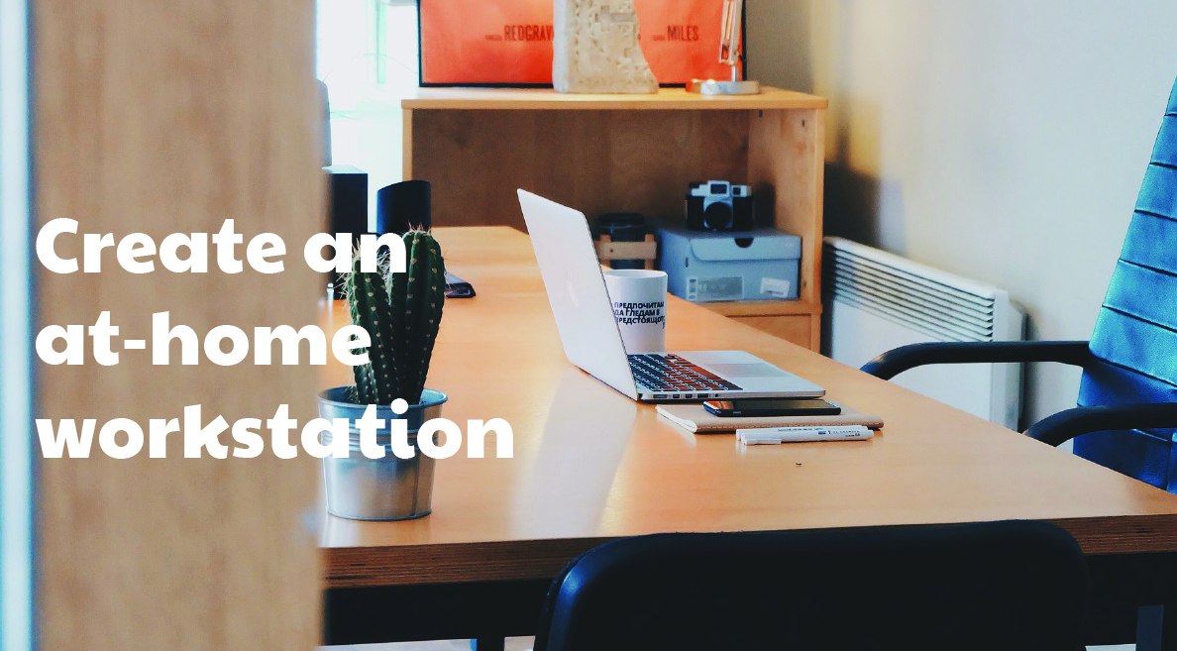

**Your Name**

CalBRE Lic#  
NMLS ID#  
555.555.5555  
youremail@mail.com  
yourwebsite.com

Broker’s Name  
Broker’s Lic #

Not enough space for a home office? Compromise with a workstation, perfect for you or the kids. Here are some tips to create space to help you get work done at home:

1. Motivate. What is your current workspace lacking, and what will make it better? Is it too cluttered, or too noisy? Identifying what’s holding you or your child back from getting work done is the first step in creating your ideal workspace.
2. Locate. If you’d like to keep an eye on your child while they do their homework, consider transforming a kitchen counter or a corner of your dining room into a work niche. Or, if you need peace and quiet to do your own work, make a space for yourself in a little-used corner of the house, like a guest room. Or, remove the doors on a closet for a built-in work nook in any room.
3. Stimulate. Choose the elements you need to inspire good work. For a child, corkboards are a great place to display things they’ll need to refer to often like schedules, math formulas and grammar rules. For you, a letter sorter and organizer can keep your space de-cluttered.
4. Generate. Select a comfortable chair and get to work!

Do you need more space to get work done at home? A new home purchase may be in your future. Contact me for help!