October

Your Name

CalBRE Lic# 555.555.5555
youremail @mail.com yourwebsite.com

Brkers Name Brkers Lic#
Four reasons to list your home in the fall
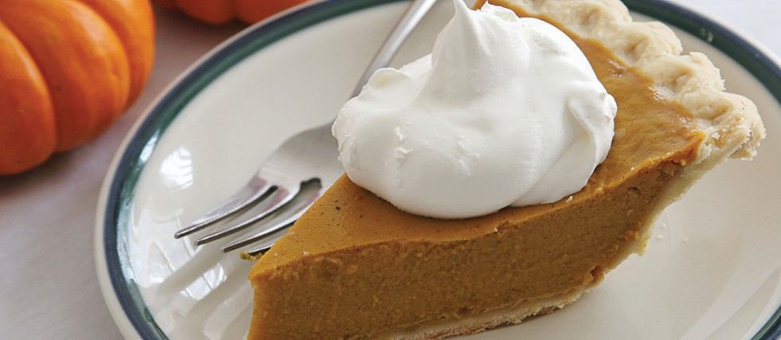You’ve likely heard that summer is the peak selling season. But listing in the fall has its advantages, too! Here are four top reasons to list your home this fall:

Perfect pumpkin pie
- 1 (15 oz) can pumpkin
- 1 (14 oz) can sweetened condensed milk
- 2 large eggs
- 1 tsp ground cinnamon
- ½ tsp ground ginger
- ½ tsp ground nutmeg
- ½ tsp salt
- 1 (9-inch) unbaked pie crust

- Preheat oven to 425 degrees. Whisk pumpkin, sweetened condensed milk, eggs, spices and salt in medium bowl until smooth. Pour into crust and bake for 15 minutes.
- Reduce oven temperature to 350 degrees and continue baking 35 to 40 minutes, or until a knife inserted 1 inch from crust comes out clean. Cool and store in refrigerator.
- Close before the tax year ends. It typically takes one to two months from signing a purchase agreement to closing, so sellers who want to sell their home before the calendar year ends need to consider listing in October.
- Buyers are more serious. Buyers who shop in the fall months are often more serious than spring and summer buyers. Many spring and summer buyers will buy if they can close before the school year starts, but the impetus for fall buyers is usually more immediate, like a job relocation or a changing family.
- More attention from agents. The busiest time of year for real estate professionals is summer. Sellers who list in summer have to compete for time with their agent, lenders and inspectors who juggle multiple clients during the peak summer months. Selling in fall means your agent can devote their full attention to marketing and selling your home.
- Fall décor is cozy. Boost your home’s appeal by making it feel like a cozy home. Tasteful fall décor like wreaths, pumpkins and festive centerpieces can help buyers picture their families in the home.
Have questions about listing your home in any season? Contact me for more information!

555.555.5555 | yourwebsite.com | youremail@mail.com

